La crisis al otro lado del charco
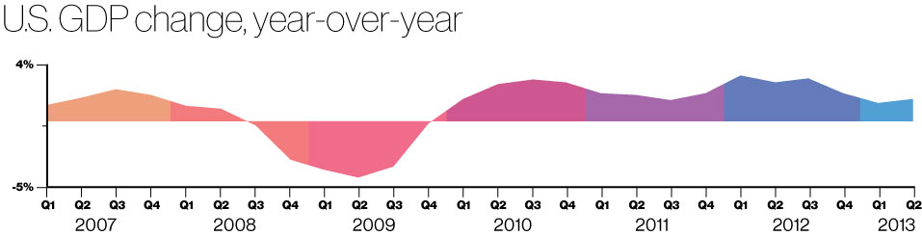
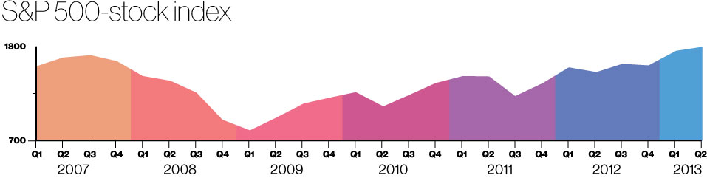
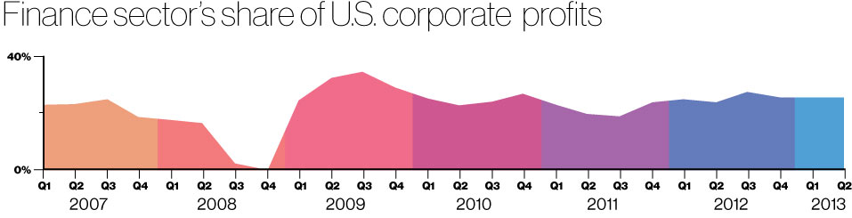
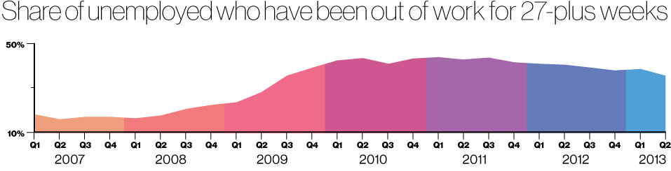
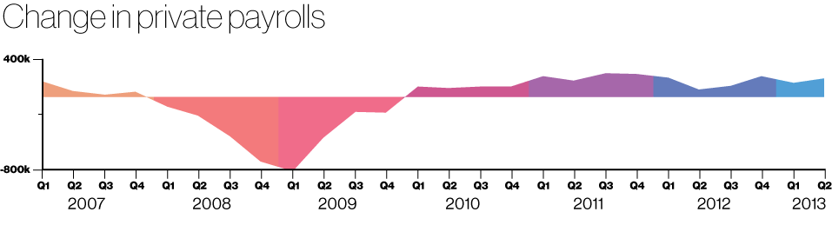
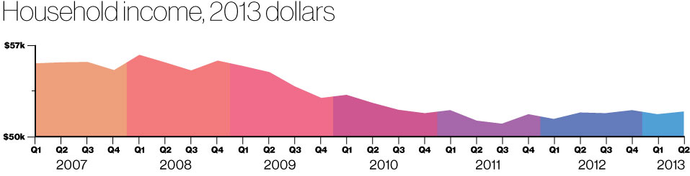
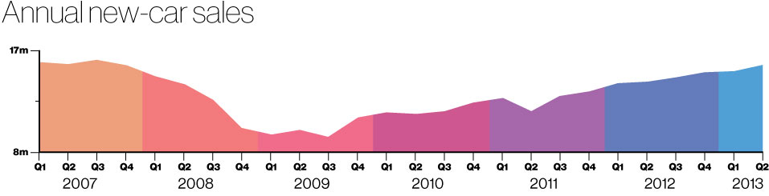
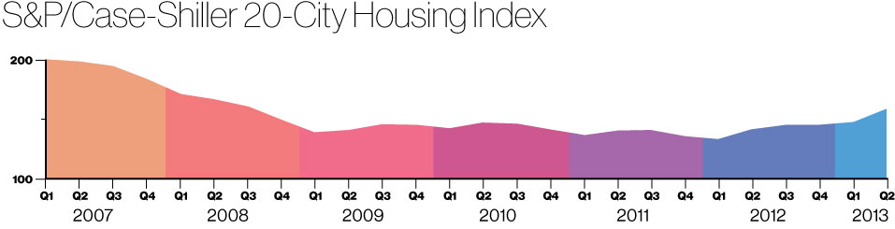
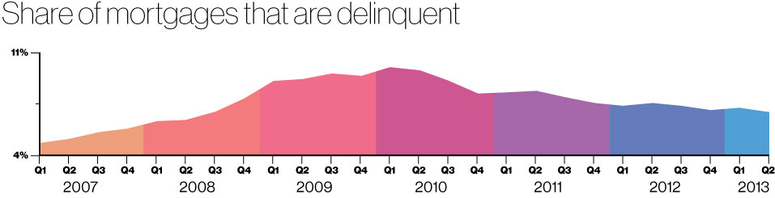
Graphic by Bloomberg Businessweek; Data: Standard & Poor’s, Sentier Research, Bureau of Economic Analysis, Bureau of Labor Statistics, Mortgage Bankers Association; Data compiled by Bloomberg
FUENTE : http://www.businessweek.com/articles/2013-09-12/2008-to-2013-the-financial-crisis-in-9-charts

